Banstead District Scout Council
County of Surrey
PARK FARM DISTRICT CAMP SITE
ACCEPTANCE OF RULES & REGULATIONS can be found at http://www.parkfarmcampsite.org/71-2/
BOOKING FORM

NAME (Please print)

GROUP DISTRICT

HOME ADDRESS

TELEPHONE NO.

MOBILE NO.

DATE(S) & TIME(S) OF HIRE : ON / /20

TO : ON / /20

NO. OF ATTENDEES

REASON FOR HIRE

BUILDINGS REQUIRED:

KITCHEN

LONG BARN

TOILETS

ROUND BARN
(Meeting room only, no sleeping. Hire charge applicable)

BBQ
(1 Weeks’ Notice Required)

ACTIVITIES:

SHOOTING to ON / /20

ARCHERY to ON / /20

CLIMBING TOWER to ON / /20

PLEASE NOTE: non-members are NOT insured for the activities above. It is the responsibility of the person completing this form to ensure they have adequate insurance for non-members. Banstead District Scout Council do not accept liability for incidents to Non-members.

£25 non-refundable deposit required at time of booking as well as £50 Damage deposit also required at time of booking which will be refunded once site has been inspected by the Site Manager or one of his team at the end of your event.

I confirm that I have read the Rules and Regulations and they will be strictly enforced by me. I confirm that the Rules and Regulations will be read to ALL the campers at the start of the camp and I accept responsibility for any loss, injury or damage caused by their infringement.

SIGNED

Once completed please email one copy to BOTH of the following:
Mark Wingett, Site Manager parkfarmhq@gmail.com
John Tickett, Bookings parkfarmbookings@bansteadscouts.co.uk

Internet Banking
Account Name: Banstead District Scout Council Account Number Account No.: 00199374
Sort Code: 30-90-44
REF: Your Name & Group

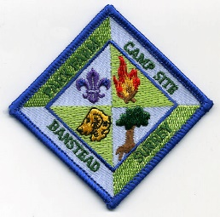

Park Farm has its own Cloth badge for use on camp blankets and items of clothing (but not uniform).
If you would like to order any at £1 each please contact Mark at parkfarmhq@gmail.com or on 07958496292

Please View our Privacy Policy at
http://www.parkfarmcampsite.org/wp-content/uploads/2019/01/Banstead-District-privacy-notice-January-2019.pdf

